Apply filters to SQL queries

**Project description**

This exercise focuses on mastering fundamental SQL filtering techniques to effectively query and analyze data. We explored how to use LIKE for pattern matching, filter data based on specific dates and times, and combine multiple filtering conditions using the logical operators AND, OR, and NOT. These skills are essential for extracting meaningful insights from databases by targeting specific subsets of information.

I recently discovered a potential security incident that occurred after business hours. To investigate this, you need to query the **log_in_attempts** table and review after hours login activity.

**Retrieve after hours failed login attempts**

**Retrieve login attempts on specific dates**

A suspicious event occurred on 2022-05-09. To investigate this event, you want to review all login attempts which occurred on this day and the day before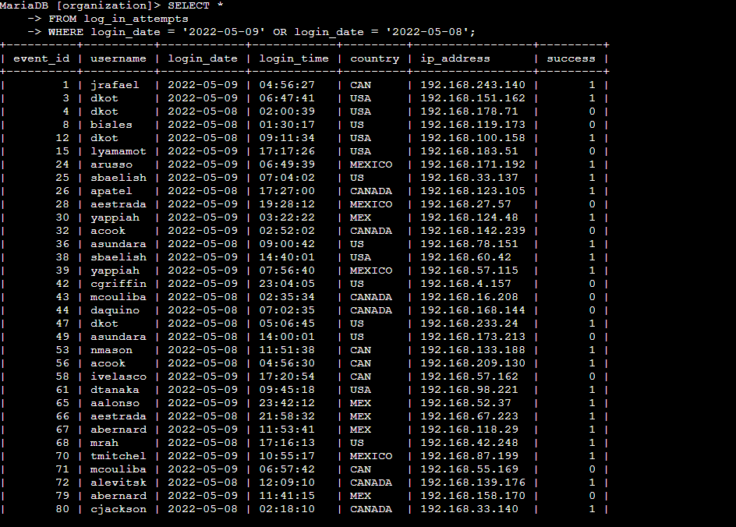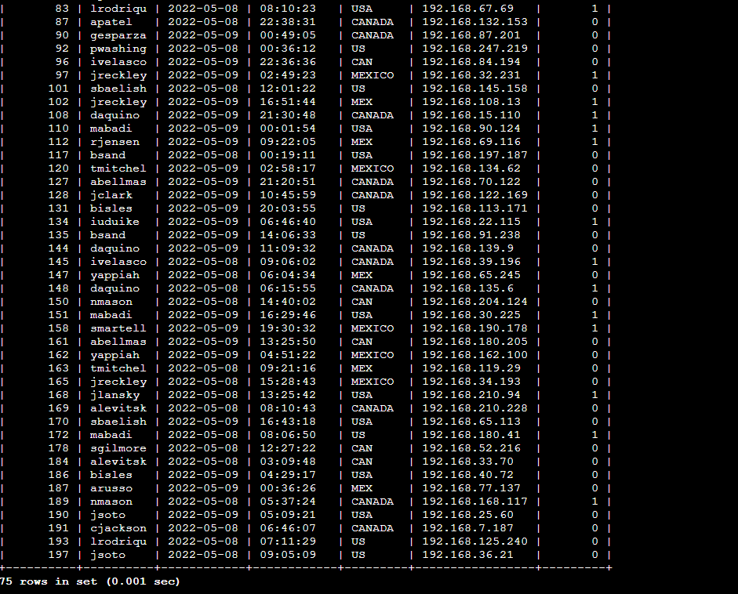

**Retrieve login attempts outside of Mexico**

There’s been suspicious activity with login attempts, but the team has determined that this activity didn't originate in Mexico. Now, you need to investigate login attempts that occurred outside of Mexico.

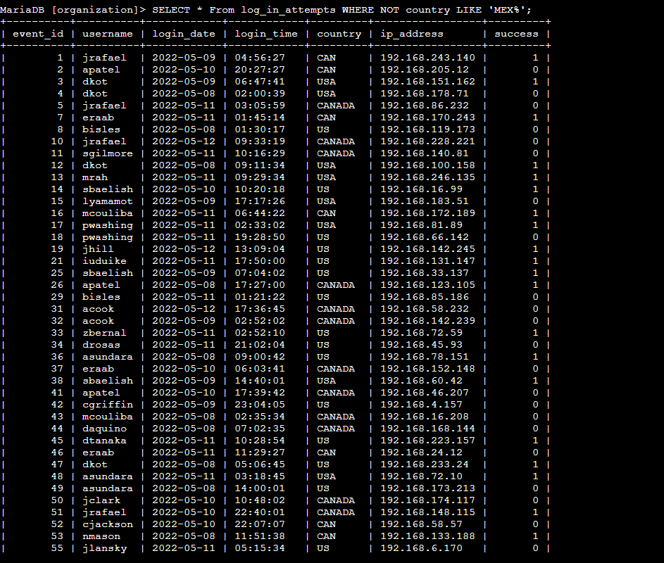

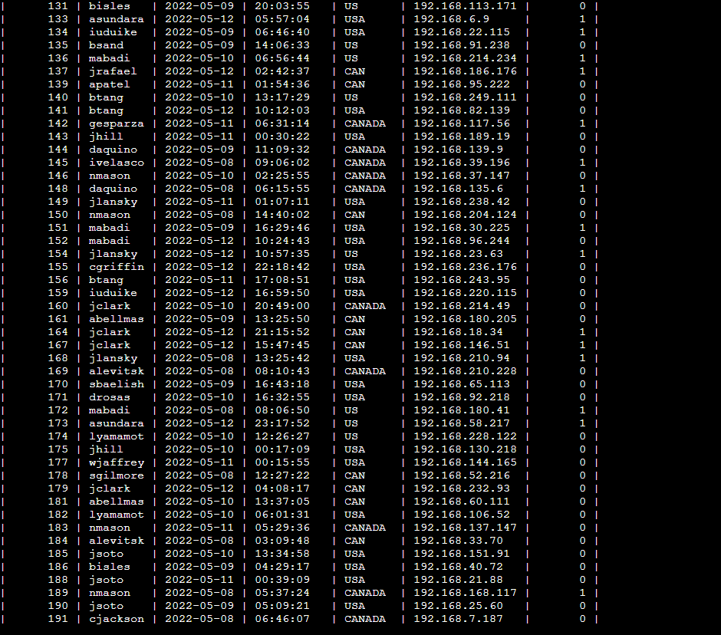

**Retrieve employees in Marketing**

Your team wants to perform security updates on specific employee machines in the Marketing department. You’re responsible for getting information on these employee machines and will need to query the employees table.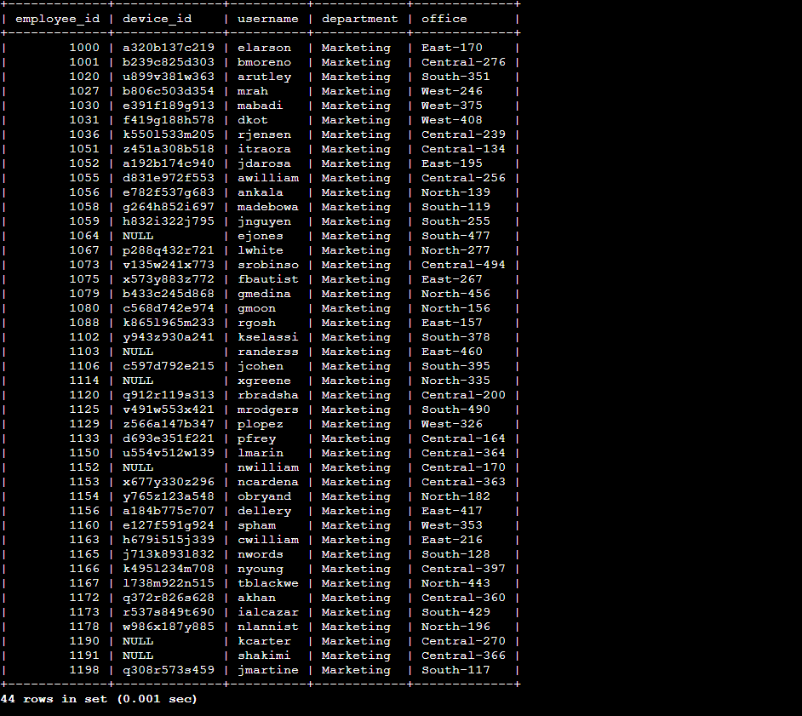

**Retrieve employees in Finance or Sales**                                              Your team now needs to perform a different security update on machines for employees in the Sales and Finance departments. 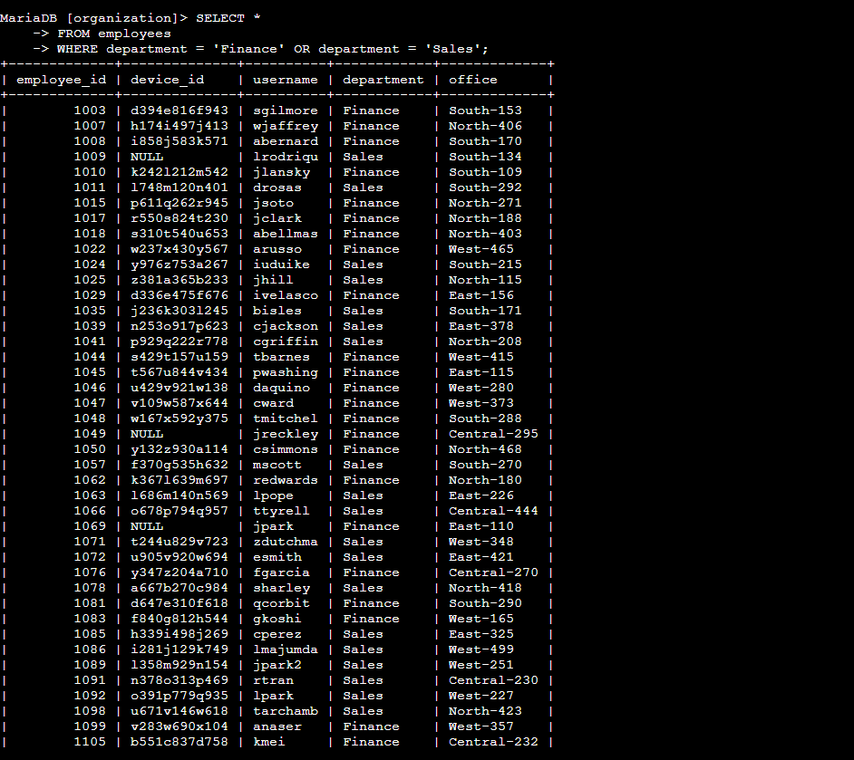

**Retrieve all employees not in IT**                                                            Your team needs to make one more update to employee machines. The employees who are in the Information Technology department already had this update, but employees in all other departments need it.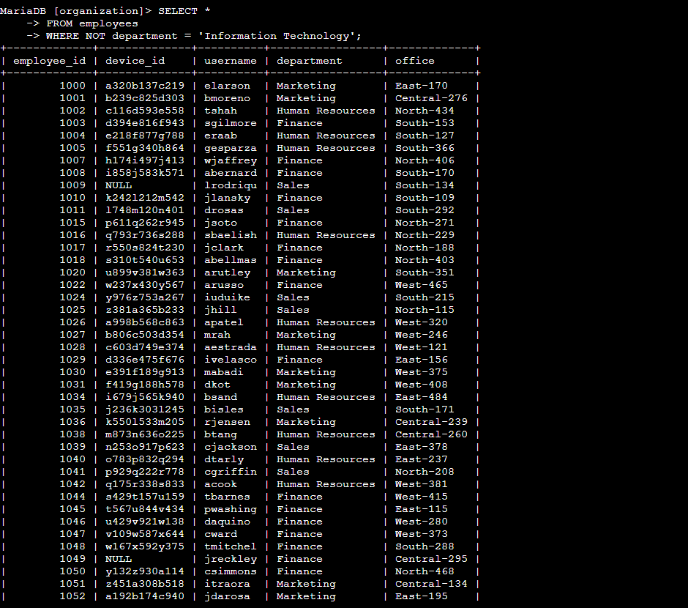

Summary

We've covered essential SQL filtering techniques, including using LIKE for pattern-based searches, applying comparisons to filter by dates and times, and combining multiple criteria with AND, OR, and NOT. These methods are fundamental for precisely selecting the data you need from a database. By applying these techniques, you can efficiently isolate specific information relevant to various scenarios, such as finding particular product names, analyzing orders within a specific timeframe, or identifying customers based on multiple attributes.